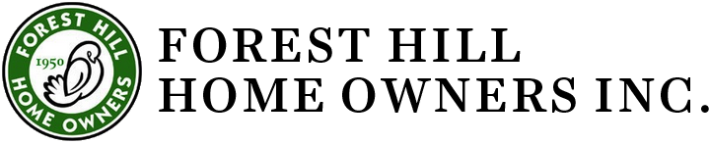
Combined Executive Committee and Board

Date: August 10, 2022, 7 pm
Meeting was held on the lawn of the Blue Cottage 2419 Lee Blvd. Cleveland Hts, OH

Present: Gretchen Mettler, Ko Carten, Fran Mentch, Beryl Tishkoff, Tony Rupcic, Chris Hubbert, Jim Havach, Donna Kolb, Jan Milic, Tracey Kirksey
Excused: Jammie Artise
Absent: Mary Rice, Lee Barbee, Jackie Kelly, Nate Wright

Agenda
- Call to order at 7:05 pm.
- The June 8, 2022 Meeting Minutes were approved.
- Treasurer’s Report-Tony distributed the Income Statement for July 2022. Tony noted that some people who gave in 2021 have not done so this year, so there has been some lag in income year to date. Tracey, Fran, and Gretchen volunteered to send a card to the former donors asking them to consider donating again this year.
- Bylaws Committee- Chris will send out an email with draft changes for the Board members to review and comment on. Until changes are approved, we will continue to use a nominating committee to provide a slate of trustees
- Standards/Preservation Committee. Because of Jo Fox’s moving out of the neighborhood, we need to designate a chair, Tony does not want to do it. Chris offered to talk with Kurt Mott about working/chairing Standards/preservation. Tony knows an architect who lives in Cleveland Heights who can volunteer guidance when needed. Tony has called on other preservation enthusiasts in the neighborhood for help when he has needed it. We may have a functioning Standards Committee, but will still need a chair.
Jim will follow-up with the city of Cleveland Heights about the issues with the roof at 1064 Hereford Rd, which the Cleveland Heights ABR will have replaced.
Fran volunteered to draft a letter to send to owners of slate/tile roofs to remind them of the standards regarding these types of roofs. Jan and Ko volunteered to take an inventory of houses with these roofs, so we can mail letters to the people who have slate and tile roofs.
- Membership – Jan has invited 25 new residents of Forest Hill to attend the Neighborhood Block Party on Rumson/Kew on August 27. She has recently distributed 4 packets to 4 new homeowners on Rumson, Kew, and Burlington.
- Blue Cottage restoration report – Beryl reported that the Forest Hill Save the Blue Cottage Committee has met since the last board meeting and developed a letter and a pledge form. These will be sent to Forest Hill neighborhood next month. The goal is to raise the $80,000 needed to repair/replace the foundation and other upgrades. The Committee is considering starting a “Go Fund Me Campaign”.
- Events Committee – Jammie was excused, no report. The July 17 Tea was cancelled because of really bad weather. There are no plans to reschedule it. The Board agreed that the Events Committee has done splendid work, but there seems to be waning interest in volunteers serving on it and few board members are able. Therefore the board is going to thank the members of the committee and offer a hiatus on planning events.
- Other business
  - Planning for the Annual Meeting- The Annual Meeting will be held on the 2nd Wednesday of November – November 9, 2022 from 7pm-9pm. Tracey volunteered to investigate a venue with AV capabilities. Gretchen will arrange Zoom for a hybrid meeting, or if needed if meeting in person is not a good idea because of COVID.
  - Dave Henry is our new webmaster.
  - Jim agreed to convene the Nominating Committee. He may chair it or find another person to be the chair.
- No New Business

Meeting concluded at 8:24 p.m.

